

OPPOSITION DIVISION

## OPPOSITION Nо B 3 170 954

**Levi Strauss & Co.**, Levi's Plaza 1155 Battery Street, 94111 San Francisco, United States of America (opponent), represented by **Bomhard IP, S.L.**, C/Bilbao, 1, 5º, 03001 Alicante, Spain (professional representative)

a g a i n s t

**Gear Up International Limited, LTD**, Vistra Corporate Services Centre, Wickham's Cay II, Road Town, VG1110 Tortola, British Virgin Islands (applicant), represented by **Dehns**, Theresienstr. 6-8, 80333 Munich, Germany (professional representative).

On 29/04/2025, the Opposition Division takes the following

# DECISION:

1. Opposition No B 3 170 954 is partially upheld, namely for the following contested goods:

Class 9: All the contested goods in this class, except for *mouse pads; USB flash drives; calculating machines; computer keyboards; chronographs [time recording apparatus]; scales; measuring instruments; cabinets for loudspeakers; microphones; loudspeakers; headphones; earphones; Selfie sticks [hand-held monopods]; digital photo frames; cameras [photography]; telescopes; protective helmets; eyeglasses; eyeglass frames; contact lenses; containers for contact lenses; eyeglass cases; sunglasses; 3D spectacles; eyeglass lenses; battery chargers; batteries, electric; power banks.*

Class 25: All the contested goods in this class.

1. European Union trade mark application No 18 643 113 is rejected for all the goods as reflected above under point 1 of this dictum. It may proceed for the remaining goods.
2. Each party bears its own costs.

# REASONS

On 11/05/2022, the opponent filed an opposition against all the goods of European Union



trade mark application No 18 643 113 (figurative mark). The opposition is based on the following registrations:

* 1. EUTM registration No 65 342, (figurative mark – earlier mark 1);

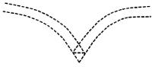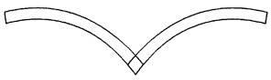

* 1. EUTM registration No 2 298 933, (figurative mark – earlier mark 2);
  2. EUTM registration No 112 862, (figurative mark – earlier mark 3);

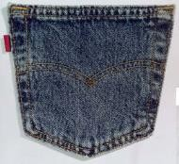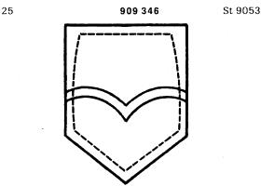

* 1. German trade mark registration No 909 346, (figurative mark – earlier mark 4).

The opponent invoked Articles 8(1)(b) and 8(5) EUTMR.

# REPUTATION — ARTICLE 8(5) EUTMR

In relation to Article 8(5) EUTMR, the opponent invoked earlier marks 1-4.

For reasons of procedural economy, the Opposition Division will first examine the opposition in relation to earlier marks 1 and 2.

According to Article 8(5) EUTMR, upon opposition by the proprietor of a registered earlier trade mark within the meaning of Article 8(2) EUTMR, the contested trade mark will not be registered where it is identical with, or similar to, an earlier trade mark, irrespective of whether the goods or services for which it is applied are identical with, similar to or not similar to those for which the earlier trade mark is registered, where, in the case of an earlier European Union trade mark, the trade mark has a reputation in the Union or, in the case of an earlier national trade mark, the trade mark has a reputation in the Member State concerned and where the use without due cause of the contested trade mark would take unfair advantage of, or be detrimental to, the distinctive character or the repute of the earlier trade mark.

Therefore, the grounds for refusal of Article 8(5) EUTMR are only applicable when the following conditions are met.

* The signs must be either identical or similar.
* The opponent’s trade mark must have a reputation. The reputation must also be prior to the filing of the contested trade mark; it must exist in the territory concerned and for the goods and/or services on which the opposition is based.
* Risk of injury: use of the contested trade mark would take unfair advantage of, or be detrimental to, the distinctive character or repute of the earlier trade mark.

The abovementioned requirements are cumulative and, therefore, the absence of any one of them will lead to the rejection of the opposition under Article 8(5) EUTMR (16/12/2010, T- 357/08, BOTOCYL / BOTOX, EU:T:2010:529, § 41; 16/12/2010, T-345/08, BOTOLIST /

BOTOX, EU:T:2010:529, § 41). However, the fulfilment of all the abovementioned conditions may not be sufficient. The opposition may still fail if the applicant establishes due cause for the use of the contested trade mark.

In the present case, the applicant did not claim to have due cause for using the contested mark. Therefore, in the absence of any indications to the contrary, it must be assumed that no due cause exists.

## Reputation of the earlier trade marks

Reputation implies a knowledge threshold that is reached only when the earlier mark is known by a significant part of the relevant public for the goods or services it covers. The relevant public is, depending on the goods or services marketed, either the public at large or a more specialised public.

In the present case, the contested trade mark was filed on 24/01/2022. Therefore, the opponent was required to prove that the trade marks on which the opposition is based had acquired a reputation prior to that date. In principle, it is sufficient that the opponent show that its marks already had a reputation on that date. While it follows from the wording of Article 8(5) EUTMR that the conditions for its application also need to be present at the time of taking the decision, and therefore the reputation of the earlier mark must subsist until the decision on the opposition is taken, any subsequent loss of reputation is for the applicant to claim and prove.

The evidence must also show that the reputation was acquired for the goods for which the opponent has claimed reputation, namely:

Class 25: *Clothing*.

The opposition is directed against the following goods:

Class 9: *Mouse pads; USB flash drives; covers for tablet computers; calculating machines; computer keyboards; bags adapted for laptops; sleeves for laptops; chronographs [time recording apparatus]; scales; measuring instruments; covers for smartphones; cases for smartphones; cabinets for loudspeakers; microphones; loudspeakers; headphones; earphones; Selfie sticks [hand-held monopods]; digital photo frames; cameras [photography]; telescopes; protective helmets; eyeglass chains; eyeglass cords; eyeglasses; eyeglass frames; contact lenses; containers for contact lenses; eyeglass cases; sunglasses; 3D spectacles; eyeglass lenses; battery chargers; batteries, electric; power banks*.

Class 25: *Adhesive bras; adhesive brassieres; boxer shorts; brassieres; camisoles; girdles; underpants; underwear; underclothing; bath robes; bathing caps; bathing suits; swimsuits; bathing trunks; bathing drawers; clothing incorporating LEDs; dressing gowns; masquerade costumes; pajamas; coats; jackets [clothing]; outer clothing; overcoats; topcoats; parkas; caps being headwear; hats; headbands [clothing]; headwear; hoods [clothing]; clothing of leather; clothing; embroidered clothing; knitwear [clothing]; layettes [clothing]; suits; waterproof clothing; shirts; short-sleeve shirts; sports jerseys; sports singlets; sweaters; jumpers [pullovers]; pullovers; tee-shirts; waistcoats [vests]; dresses; skirts; skorts; hosiery; socks; stockings; leggings [trousers]; trousers; pants (Am.); aprons [clothing]; belts [clothing]; braces for clothing [suspenders]; suspenders; ear muffs [clothing]; gloves [clothing]; neckties; pockets for clothing; ready-made linings [parts of clothing]; scarves; scarfs; shawls; shirt yokes; shower caps; sleep masks; veils [clothing]; rainwear; athletic wear [sportswear]; wind-resistant jackets; down jackets; childrens' clothing; blouses; blazers; jeans; sweatpants; shorts; cardigans; boots; footwear; shoes; slippers; sports shoes; fittings of metal for footwear; non-slipping devices for footwear*.

In order to determine the mark’s level of reputation, all the relevant facts of the case must be taken into consideration, including, in particular, the market share held by the trade mark, the

intensity, geographical extent and duration of its use, and the size of the investment made by the undertaking in promoting it.

The opponent submitted evidence to support this claim on 25/11/2024 (continuation of proceedings was granted). As the opponent requested that certain commercial data contained in the evidence be kept confidential vis-à-vis third parties, the Opposition Division will describe the evidence only in the most general terms without divulging any such data. The evidence consists of the following documents:

* **Annexes 1, 13-15 of Enclosure 2**: Printouts of the website statista.com, containing:
  + the total number of the opponent’s company-operated retail stores in 2023. The number of stores in Europe is 291. The document is in English and dated in March 2024. There is no reference to the opponent’s marks, only to the opponent’s company name.
  + a text in German which is translated, according to the opponent, into ‘Global sales of Levi Strauss in the years 2005 to 2023’, dated in January 2024. The amount of sales is substantial. There is no reference to the opponent’s marks.
  + Data on the total population of the European Union in 2022. The text is in English and dated on 04/07/2024. There is no reference to the opponent’s marks.
  + a text in German, the translation of which, according to the opponent, is ‘Jeans brands by number of consumers in Germany in 2023’, dated in July 2024. There is no reference to the opponent’s marks.
* **Annex 2 of Enclosure 2**: Labels and leaflets of the opponent’s jeans and an excerpt of the book by Lynn Downey (LS&CO historian). According to the text of one leaflet, ‘the distinctive double arc of stitching – known as the Arcuate design – has graced the back pockets of the pants since LS&CO. first made denim clothing in 1873’. There are pictures of the opponent’s goods bearing marks, such as 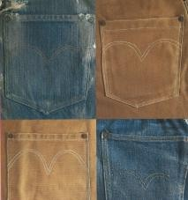. These documents are in English and undated (although there are references to the years 1873, 1890, 1990, 1995 and 1954). There is also a document on the opponent’s history and time lines, elaborated by the opponent. It contains an excerpt from an article of Pacific Rural Press dated on 28/06/1873, about a new fastening system. It does not contain references to the opponent’s marks, but to the opponent’s company name.
* **Annex 3 of Enclosure 2**: Printout from the opponent’s website, which contains an article with the title ‘Happy 75th Anniversary, Arcuate! 5 Facts About Our Pocket Design’ and contains a picture of the opponent’s goods bearing the mark: 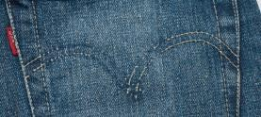. According to the article, ‘Our back pocket stitching on Levi’s® jeans is what we call the Arcuate, a unique Levi’s® identifier that has been used on our jeans since they were first created in1873’. The text is in English and dated on 15/11/2018.
* **Annex 4 of Enclosure 2**: Excerpts of catalogues showing, inter alia, jeans with the opponent’s marks: 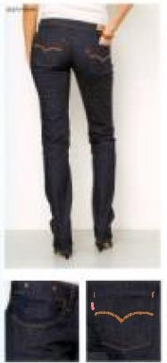, 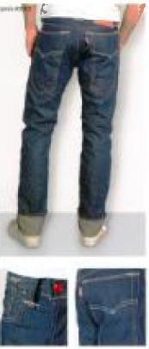, 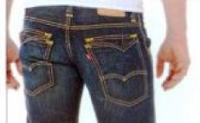, 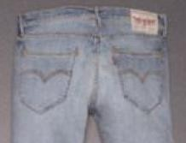. The catalogues are dated between 2007 and 2011.
* **Annex 5 of Enclosure 2:** Excerpts of publications in online magazines (Elle, Glamour, Vanity Fair and Vogue), published between 24/08/2017 and 17/11/2021 in Spanish, French, Italian, German and English, showing the opponent’s jeans,

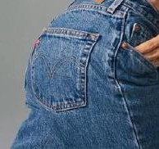majority of which bears the marks: 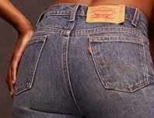, 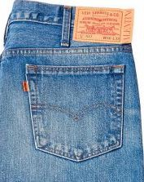 , 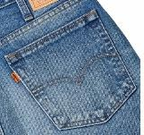

,

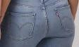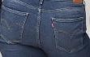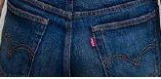

, , , ,

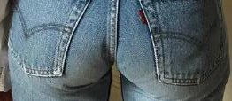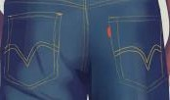,  , , ,

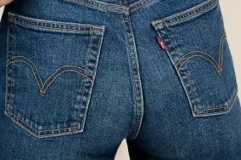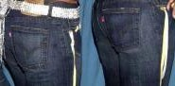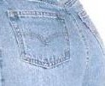

. , .

* **Annexes 6 and 7 of Enclosure 2:** Excerpts of the opponent’s advertising campaigns dated between 1985 and 2009 (Annex 6) and between 2021 and 2022 (Annex 7). The opponent’s goods bearing the following marks are visible in the campaigns dated

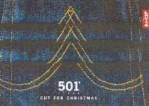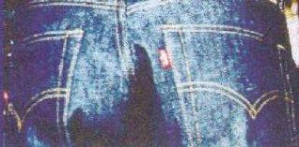in 2004: , in 2009: , 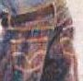 and 2022: 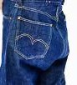 .

* **Annex 8 of Enclosure 2:** Articles published in online media (CBS News, Campaign, Collater.al, Wonderland, The Drum) between 29/06/2010 and 17/06/2024, on the opponent’s advertising campaigns. The opponent’s marks are visible in some of those campaigns: , 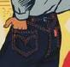,  . The articles are in English.
* 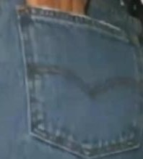**Annex 9 of Enclosure 2:** Printouts from online websites (YouTube, the opponent’s website and magazines such as Vogue) showing collaborations of the opponent with artists, influencers, foundations and other companies (such as Beyoncé, Surf Rider Foundation Europe, McLaren, Kenzo, Crocs, Emma Chamberlain, Naomi Osaka, Hailey Bieber, Marisa Jara), during the years 2021-2024. The opponent’s goods bearing the following marks appear in some pictures: 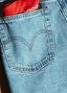 , ,

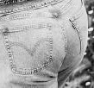(campaigns with Surf Rider Foundation Europe, Hailey Bieber and

Marisa Jara).

* **Annex 10 of Enclosure 2**: Printouts from the opponent’s profiles in social media (Instagram, TikTok, YouTube, Facebook, Pinterest). Some posts contain the

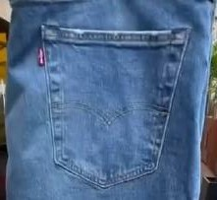opponent’s goods bearing the following marks: 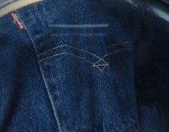,

,

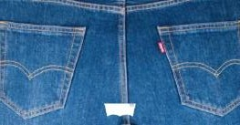

.

* **Annex 11 of Enclosure 2**: Printouts from the opponent’s website with a list of the countries in Europe where the opponent operates (according to the opponent) and screenshots of the opponent’s website in French, Italian, German and Spanish. In all the printouts the opponent’s goods bearing the following mark are visible:



.

* **Annex 12 of Enclosure 2**: Affidavit of the opponent’s Associate General Counsel (IP & Marketing) stating that the official expansion of the opponent’s into Europe dates back to1965. The document also shares figures related to the revenue generated with the sales of the opponent’s bottoms (jeans, trousers, shorts and skirts) in the EU between the years 2014 to 2021. The figures are substantial. It is also stated that the vast majority of the opponent’s bottoms display the following opponent’s marks:

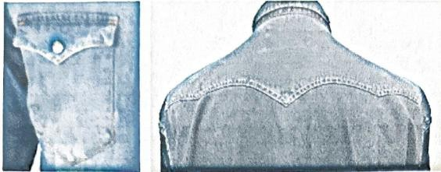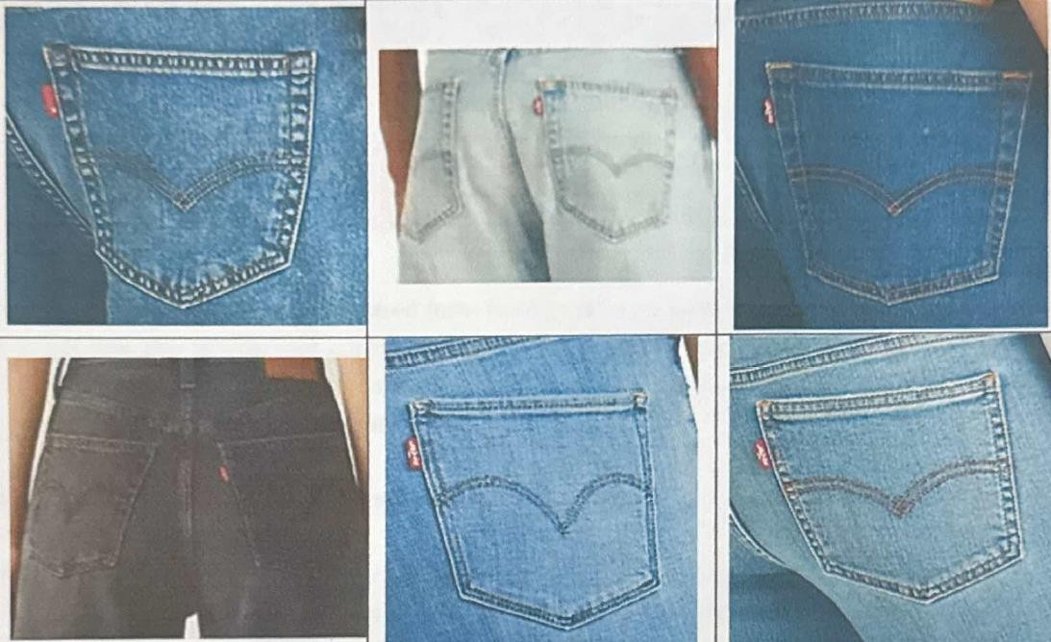. According to the document, also the backs of shirts and jackets display the opponent’s marks:

.

The document further contains two exhibits:

* + Exhibit 1: a printout from the website euromonitor.com, showing the countries grouped under the category ‘Western Europe’: Austria, Belgium, Cyprus, Denmark, Finland, France, Germany, Gibraltar, Greece, Iceland, Ireland, Italy, Liechtenstein, Luxembourg, Malta, Monaco, The Netherlands, Norway, Portugal, Spain, Sweden, Switzerland, Turkey and United Kingdom. The text is in English and there is a reference to the year 2024.
  + Exhibit 2: a table showing the retail value of the women’s and men’s jeans corresponding to various companies between the years 2014 and 2023. The opponent’s company is listed in the first position, ahead of other companies such as Diesel, Tommy Hilfiger, Replay, Calvin Klein, Guess, etc. According to the document, the source is ‘Apparel and Footwear: Euromonitor from trade sources/national statistics’. The document is in English and undated. There is no reference to the opponent’s marks, only to the opponent’s company name.

The Affidavit is in English and dated on 22/11/2024.

* **Annex 16 of Enclosure 2**: Excerpts of publications in online newspapers (Bild, La Vanguardia, De Telegraaf, Spiegel, El País, Frankfurter Rundschau, Le Figaro, The Guardian, la Repubblica, El Mundo, Zeit Magazin, Long John, Süddeutsche Zeitung, Heddels), published between 23/01/2012 and 23/09/2024 on the opponent’s company, in English, German and Spanish. In some of these publications appear pictures of the opponent’s goods bearing the marks: 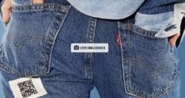,

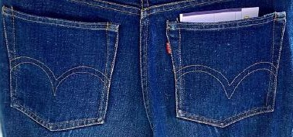, 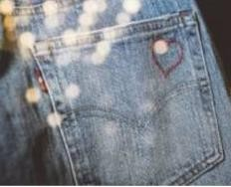, 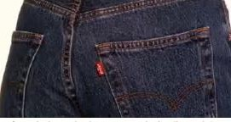, 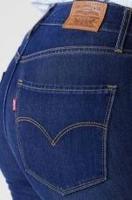, 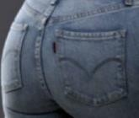,

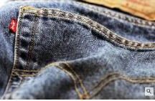, , , .

* **Annex 17 of Enclosure 2**: Excerpts of decisions from national courts in Italy, Belgium and Germany regarding the opponent’s ‘Arcuate’ sign, dated between 2011 and 2020, accompanied by translations into English. These judgments recognized the reputation of the opponent’s ‘Arcuate’ sign.
* **Annex 18 of Enclosure 2**: Survey conducted by Millward Brown during November 2003 in Spain on the opponent’s sign 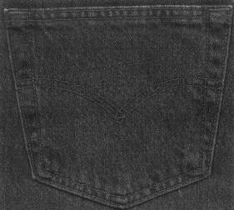. According to the document, there were 1015 respondents interviewed, who were between 15 and 65+ years old, male and female, from different social classes and residing in various cities in Spain. To the question: ‘Here is a photo of the back pocket of a pair of jeans. What is your first thought when you look at this picture?’, 22% of the respondents answered spontaneously, ‘Levi’s’. From the respondents who had not made any specific brand association to that question, with aided association (thinking of brands in particular and selection from a pre-determined list), 23% and 9% of them, respectively, mentioned ‘Levi’s’. The results of the survey are presented in English and dated in December 2003.

It is worth mentioning that in its observations, the opponent refers to product placement in films and TV series, such as ‘Magic Mike XXL’ (2015), ‘Ted 2’ (2015), ‘Marvel's The Runaways’ (2017), ‘We can be heroes’ (2020), ‘Drive’ (2012), ‘No country for Old Men’ (2007) or ‘Thelma and Louise’ (1992) and attaches screenshots from the abovementioned films and series:

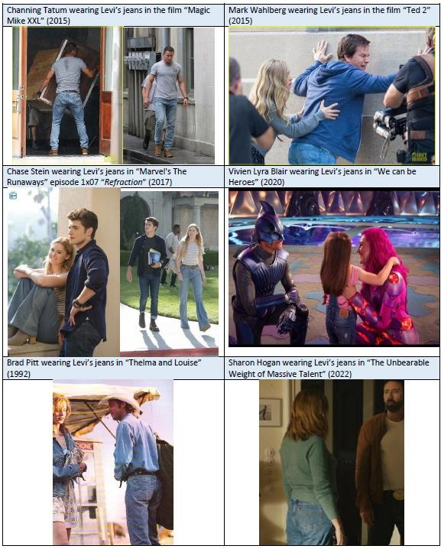

In all these pictures the opponent’s goods bearing the earlier marks are visible, although in four out of the six pictures is more evident than in the remaining two pictures.

* **Enclosure 3**: Document elaborated by GfK/ Kantar on brand shares in the jeans market in Germany, UK, France, Spain and Italy for the years 2021-2023. The opponent’s company’s market share is substantial. However, the opponent’s marks do not appear in the document.
* **Enclosure 4**: Excerpt of a brief submitted by the opponent in court proceedings in Germany in April 2024. According to the text, the ‘defendant's "Arcuate" marks had a very broad scope of protection in 2006 - as they did before and after - due to their

very strong distinctiveness. […] it is certain that the defendant was the first manufacturer to create brand awareness for the design of back pockets among consumers, which determines the public perception and leads to the assumption of trademark use of such designs. This can be seen, for example, in the publication by Tanja Roppelt, "Abenteuer Jeans - Eine Reise zu den Ursprüngen der blauen Hose", Bamberg 2008. […] In the article in the magazine "ELLE" already submitted as Appendix B 1, the "Arcuate" is also prominently mentioned in its significance as a trademark (emphasis on this side): *"Trademark of Levi's […] Another unique feature is* ***the famous 'Arcuate Stitching',*** *the double bow embroidery on the back pockets, which makes the jeans unmistakable.*

*Where can I buy genuine Levi's jeans?*

*Levi's jeans are available in Levi's stores, on the Levi's website and at authorized retailers. In addition, look for the tab device on the back right pocket and* ***the iconic Arcuate stitching on the back pockets (see trademark)*** *to ensure that* ***it is an original product.****"*. The text also contains excerpts from different European courts. It is in English and dated on 26/04/2024.

* 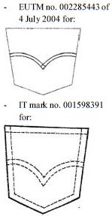**Enclosure 5**: A table containing relevant quotes from different national judgments of the opponent’s marks (Italy, Belgium, Germany, Spain, France), such as

, 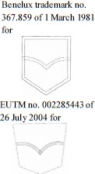 , 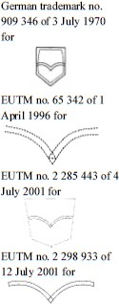 . These judgments concluded the high level of recognition of the opponent’s marks.

On the basis of the above the Opposition Division concludes that earlier marks 1 and 2 have a certain reputation at least in Spain, France, Italy and Germany for *jeans* in Class 25.

An overall assessment of the evidence reveals that the earlier marks have been subject to long-standing and intensive use for decades since their launch in 1873 and are generally known in Spain, France, Italy and Germany. In particular, the articles in online magazines such as Elle, Glamour, Vanity Fair and Vogue (**Annex 5 of Enclosure 2**), specialized media such as CBS News, Campaign, Collater.al, Wonderland, The Drum (**Annex 8 of Enclosure 2**), online newspapers such as Bild, La Vanguardia, De Telegraaf, Spiegel, El País, Frankfurter Rundschau, Le Figaro (**Annex 16 of Enclosure 2**), the product placement in films and TV series, as well as the documents on the opponent’s advertising campaigns between 1985 and 2009 (**Annex 6 of Enclosure 2**) and between 2021 and 2022 (**Annex 7 of Enclosure 2**) suggest that the trade marks have a consolidated position on the market.

This reasoning is also confirmed by the excerpts of decisions from national courts submitted by the opponent (**Annex 17 of Enclosure 2 and Enclosures 4 and 5**). Although the decisions adopted in a Member State or in a state that is not a member of the European Union are not binding upon the Office (24/03/2010, T-363/08, Nollie, EU:T:2010:114, § 52), their reasoning and outcome should still be duly considered, particularly when the decision has been taken in the Member State that is relevant to the proceedings. National courts have a thorough knowledge of the specific characteristics of their Member State, in particular as regards the marketplace reality in which goods and services are marketed and the customer perception of signs. This may be relevant for the assessment made by the Office. Therefore, as national decisions are admissible evidence and have evidentiary value if they

originate from Member States that are the relevant territory for the proceedings, the decisions submitted are taken into account as an additional indicator of the long-standing use of the figurative device of earlier marks 1 and 2 in the present proceedings.

However, the evidence does not succeed in establishing that the trade marks have a reputation for all the goods for which reputation has been claimed. The evidence mainly relates to *jeans*, whereas there is no or little reference to the remaining goods falling under the broad category of *clothing*. This is clear from the pictures submitted in the vast majority of documents, which show jeans, and in particular, their back pockets, where the trade marks of the opponent are, in their vast majority, placed.

## The signs

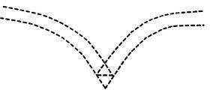

Earlier mark 1

Earlier mark 2

Earlier trade marks

Contested sign

The relevant territory is the European Union.

The global appreciation of the visual, aural or conceptual similarity of the marks in question must be based on the overall impression given by the marks, bearing in mind, in particular, their distinctive and dominant components (11/11/1997, C-251/95, Sabèl, EU:C:1997:528, § 23).

The earlier marks depict two curved lines that converge in the centre of the signs, with a pointed end. This pointed end contains in it the figure of a triangle in the earlier mark 1 and the figure of a rhombus in the earlier mark 2. The curves are less open in the earlier mark 1 and more open in the earlier mark 2. In both marks the curved lines point upwards. The earlier mark 1’s contour is depicted with discontinued lines, resembling stitches, while the earlier mark 2’s contour is solid. Both marks are white in the inner side of their black lines. The endings of the lines are open in the earlier mark 1 and closed in the earlier mark 2.

The contested sign consists of two curved thick black lines with a pointed end where they converge. The curves, placed on the sides of the pointed end, are not prominent. The endings of the line are rounded.

According to the opponent, the signs form a ‘kind of seagull shape’. However, linking the signs’ lines to the shape of a seagull requires several mental steps and it is not obvious in relation to the relevant goods. Therefore, this interpretation must be set aside.

None of the trade marks’ elements are allusive or descriptive in relation to the goods covered by the trade marks in dispute. Therefore, they are distinctive.

All the signs are purely figurative marks and have no elements that could be considered more distinctive or more dominant (eye-catching) than other elements.

**Visually**, the signs coincide only to the extent that they consist of curved lines with a pointed end where their curves converge. The signs differ in their shape fill, the angle of their curves (less open in the earlier marks and more open in the contested sign), and in the small figures placed in the centred pointed end which are visible in the earlier marks.

Therefore, the signs are visually similar to, at most, a low degree.

Purely figurative signs are not subject to a phonetic assessment. As both signs are purely figurative, it is not possible to compare them **aurally**.

**Conceptually**, neither of the signs has a clear obvious meaning and, therefore, a conceptual comparison is not possible.

## The ‘link’ between the signs

As seen above, the earlier marks are reputed and the signs are visually similar to some extent. In order to establish the existence of a risk of injury, it is necessary to demonstrate that, given all the relevant factors, the relevant public will establish a link (or association) between the signs. The necessity of such a ‘link’ between the conflicting marks in consumers’ minds is not explicitly mentioned in Article 8(5) EUTMR but has been confirmed by several judgments (23/10/2003, C‑408/01, Adidas, EU:C:2003:582, § 29, 31; 27/11/2008, C‑252/07, Intel, EU:C:2008:655, § 66). It is not an additional requirement but merely reflects the need to determine whether the association that the public might establish between the signs is such that either detriment or unfair advantage is likely to occur after all of the factors that are relevant to the particular case have been assessed.

Possible relevant factors for the examination of a ‘link’ include (27/11/2008, C‑252/07, Intel, EU:C:2008:655, § 42):

* + the degree of similarity between the signs;
  + the nature of the goods and services, including the degree of similarity or dissimilarity between those goods or services, and the relevant public;
  + the strength of the earlier mark’s reputation;
  + the degree of the earlier mark’s distinctive character, whether inherent or acquired through use;
  + the existence of likelihood of confusion on the part of the public.

This list is not exhaustive and other criteria may be relevant depending on the particular circumstances. Moreover, the existence of a ‘link’ may be established on the basis of only some of these criteria.

The earlier marks have a normal degree of inherent distinctiveness and enjoy certain reputation in relation to *jeans* in Class 25. The signs are visually similar to a low degree, whereas the aural and conceptual comparison is not possible.

The contested goods are the following:

Class 9: *Mouse pads; USB flash drives; covers for tablet computers; calculating machines; computer keyboards; bags adapted for laptops; sleeves for laptops; chronographs [time recording apparatus]; scales; measuring instruments; covers for smartphones; cases for smartphones; cabinets for loudspeakers; microphones; loudspeakers; headphones; earphones; Selfie sticks [hand-held monopods]; digital photo frames; cameras [photography]; telescopes; protective helmets; eyeglass chains; eyeglass cords; eyeglasses; eyeglass frames; contact lenses; containers for contact lenses; eyeglass cases; sunglasses; 3D spectacles; eyeglass lenses; battery chargers; batteries, electric; power banks*.

Class 25: *Adhesive bras; adhesive brassieres; boxer shorts; brassieres; camisoles; girdles; underpants; underwear; underclothing; bath robes; bathing caps; bathing suits; swimsuits; bathing trunks; bathing drawers; clothing incorporating LEDs; dressing gowns; masquerade costumes; pajamas; coats; jackets [clothing]; outer clothing; overcoats; topcoats; parkas; caps being headwear; hats; headbands [clothing]; headwear; hoods [clothing]; clothing of leather; clothing; embroidered clothing; knitwear [clothing]; layettes [clothing]; suits; waterproof clothing; shirts; short-sleeve shirts; sports jerseys; sports singlets; sweaters; jumpers [pullovers]; pullovers; tee-shirts; waistcoats [vests]; dresses; skirts; skorts; hosiery; socks; stockings; leggings [trousers]; trousers; pants (Am.); aprons [clothing]; belts [clothing]; braces for clothing [suspenders]; suspenders; ear muffs [clothing]; gloves [clothing]; neckties; pockets for clothing; ready-made linings [parts of clothing]; scarves; scarfs; shawls; shirt yokes; shower caps; sleep masks; veils [clothing]; rainwear; athletic wear [sportswear]; wind-resistant jackets; down jackets; childrens' clothing; blouses; blazers; jeans; sweatpants; shorts; cardigans; boots; footwear; shoes; slippers; sports shoes; fittings of metal for footwear; non-slipping devices for footwear*.

There is certain connection between the contested goods in Class 25, which refer to various items of clothing (some of them include the opponent’s reputed jeans and even this term is identically contained among the contested goods), as well as various item of headwear and footwear, including specific parts. These goods contribute, in general, to dress and cover the human body and pertain to the fashion market sector. In this regard, these goods are promoted in similar commercial contexts and are often marketed as interrelated elements of a certain look or even lifestyle, for example displayed together on mannequins, in shop windows or the same pages of fashion catalogues and press articles devoted to fashion trends.

Regarding the contested *fittings of metal for footwear; non-slipping devices for footwear,* they also have a connection to the opponent’s jeans, since they contribute to the overall look and aspect of people. Although these items may not coincide in the same distribution channels, they are of interest to the same public. The world of fashion consist of many sectors, including the manufacturing and DIY sectors. Therefore, the contested *fittings of metal for footwear; non-slipping devices for footwear* and the opponent’s jeans, pertain to the same general sector of fashion and its accessories, including its parts, such as these contested goods.

The Opposition Division observes that there is a new trend of wearing a smartphone in a fashionable case or eyeglasses around a neck, or a laptop on the shoulder, and some luxury brands are already selling these goods together. The world of fashion is starting to rethink the way people carry their phones, eyeglasses and laptops, creating lavish leather carrying cases and designer pouches to go with the latest in high-end looks. Most of these designer cases and bags are worn as necklaces or bags. Some have a transparent window to make checking the phone/tablet easy, but the most involved designs are encased in leather and other delicate materials that keep the phone/tablet completely covered. Furthermore, in the modern world, smartphone and tablet covers, cases have a certain aesthetic complementary character to clothing in the sense that all are fashion articles which the public wears and matches to underline their personality. The same is applicable to eyeglass chains and cords, which can be produced out of cloth or metal materials also used in the jeans industry.

Therefore, although, it also has to be borne in mind that even the average consumer is reasonably observant and circumspect and will clearly be aware of the market reality and that the nature of the reputed goods is different per se or not similar to the contested *covers for tablet computers; bags adapted for laptops; sleeves for laptops; covers for smartphones; cases for smartphones; eyeglass chains; eyeglass cords* in Class 9, an association with the earlier mark remains still possible, especially when taking into account the similarity between the signs and the reputation of the earlier mark as well as market reality, as mentioned above, and the fact that the fashion industry consists of many separate but interdependent sectors. These sectors include textile design and production, fashion design and manufacturing, fashion retailing, marketing and merchandising, fashion shows, and media and marketing. Each sector is devoted to the goal of satisfying consumer demand for apparel under conditions that enable participants in the industry to operate at a profit.

Therefore, it is likely that the contested sign will bring the earlier mark into the mind of the relevant consumers in relation to the above-mentioned contested goods.

Therefore, taking into account and weighing up all the relevant factors of the present case, it must be concluded that when encountering the contested mark in relation to the abovementioned goods, the relevant consumers in Spain, France, Italy and Germany will be likely to associate it with the earlier signs, that is to say, establish a mental ‘link’ between the signs. However, although a ‘link’ between the signs is a necessary condition for further assessing whether detriment or unfair advantage are likely, the existence of such a link is not sufficient, in itself, for a finding that there may be one of the forms of damage referred to in Article 8(5) EUTMR (26/09/2012, T-301/09, CITIGATE / CITICORP et al., EU:T:2012:473,

§ 96).

However, there is no link between the opponent’s reputed *jeans* in Class 25 and the remaining contested goods in Class 9. These goods are computer peripherals and goods designed to use them, data storage devices, calculating machines, audio reproducing and image capturing devices, display devices, data recorders, measuring instruments, telescopes, helmets, lenses and their containers, eyeglasses and its frames, sunglasses, batteries and their chargers.

According to the opponent, ‘[c]hronographs include watches, and so do measuring instruments. Watches are of course a typical and frequent area for brand extension of fashion brands.’. However, the chronographs classified in Class 9 are considered data (time) recorders and do not include watches, which are classified in Class 14. Therefore, this reasoning must be set aside.

The opponent also claims that ‘mouse pads, USB drives and power banks are frequently used as merchandise items. They are used and encountered on a daily basis and are therefore closely connected in consumers’ minds with fashion’. In the same line, the

opponent explains that ‘[a]s regards selfie sticks, these are used and perceived as smartphone accessories and also their style is important to fashionistas. “Tech is in fashion” therefore applies to these goods as well’. The Opposition Division cannot concur with the opponent in this regard. Although these items may be purchased taking into account their visual design, they are not commonly worn on the body but rather displayed in one’s room or office, where they can match the furniture or show the owner’s tastes or hobbies.

According to the opponent,

Headphones (= loudspeakers, earphones) are often incorporated in fashion items and have in fact been integrated into fashion. This is understandable bearing in mind that they are right on people’s heads, and consumers proudly wear them as part of their persona style, just like shoes and sunglasses. Speaking of which – there are sunglasses that incorporate headphones.

In order to support its arguments, the opponent submits as Enclosure 8 an article titled ‘Headphones in Fashion: Accessory or Utility?’, in which although it is said that ‘headphones add this unexplainable improvement in fashion’, it is concluded ‘You should buy a pair that makes you happy, no matter the ever changing standards of the fashion world – it's ultimately up to you’.

In the same vein, the opponent claims,

Of course also eyewear and related accessories are readily linked to the fashion sector because these, too, are a frequent area for brand extension. Consumers are therefore accustomed to seeing the same trade marks on clothing times as in the eyewear sector. In fact, the Opponent itself offers glasses and sunglasses under its Levi’s mark on its Amazon store in the EU countries.

In this regard, the opponent submits as Enclosure 10 a screenshot of a retailer website offering glasses and sunglasses from the opponent, albeit under another sign (different from the opponent’s trade marks here analysed).

Regarding the contested protective helmets, the opponent highlights that ‘[c]onsumers would not be surprised to encounter a fashion brand applied to a helmet; after all, also helmets are increasingly carefully chosen to contribute to the overall look and image of the wearer.’

These arguments of the opponent revolve around the fashion nature of the said contested goods. However, there is no evident relation between the markets of the reputed goods and these specific goods. The evidence presented by the opponent, limited to one press article (Enclosure 8) and the printout of a website (Enclosure 10) is not enough to show the relationship between the market sectors of the remaining contested goods and the market sector of fashion.

The Opposition Division notes that the opponent has not provided a cogent line of arguments or enough evidence with a view to establishing a relation between the reputed goods and the remaining contested goods in question. Therefore, the association between the conflicting marks in the mind of consumers remains unexplained and unaccompanied by any arguments or evidence from the opponent.

While the relevant sections of the public for the goods covered by the conflicting marks may overlap to some extent, the reputed goods and the above-mentioned contested goods are so different that the later mark is unlikely to bring the earlier mark to the mind of the relevant public. The sectors in which the contested goods pertain and the one of the reputed goods are far-removed and there is no market reality that would indicate otherwise. In the opinion of the Opposition Division, it is not plausible to assume that a producer of clothing for

women, men or children, would move into manufacturing of specific articles or devices, such as the remaining contested goods, in the fields of electronics, calculation, measuring, audio, photography, optics and electricity accumulation.

Therefore, taking into account and weighing up all the relevant factors of the present case, the Opposition Division concludes that – as far as the remaining contested *mouse pads; USB flash drives; calculating machines; computer keyboards; chronographs [time recording apparatus]; scales; measuring instruments; cabinets for loudspeakers; microphones; loudspeakers; headphones; earphones; Selfie sticks [hand-held monopods]; digital photo frames; cameras [photography]; telescopes; protective helmets; eyeglasses; eyeglass frames; contact lenses; containers for contact lenses; eyeglass cases; sunglasses; 3D spectacles; eyeglass lenses; battery chargers; batteries, electric; power banks* in Class 9 are concerned – it is unlikely that the public under analysis will make a mental connection between the signs in dispute, that is to say, establish a ‘link’ between them. Therefore, the opposition is not well founded under Article 8(5) EUTMR and must be rejected insofar as the abovementioned contested goods are concerned.

The above conclusion on the absence of a ‘link’ between the signs concerns not only the Spanish-, French-, Italian- and German-speaking parts of the relevant public, among which the earlier trade marks enjoy reputation, but also the rest of the relevant public in the European Union. Other parts of the public than the abovementioned parts will not make a link, since they are not familiar with the earlier marks, and the evidence submitted does not show that the marks have a reputation in territories other than Spain, France, Italy and Germany.

## Risk of injury

Use of the contested mark will fall under Article 8(5) EUTMR when any of the following situations arise:

* + it takes unfair advantage of the distinctive character or the repute of the earlier mark;
  + it is detrimental to the repute of the earlier mark;
  + it is detrimental to the distinctive character of the earlier mark.

Although detriment or unfair advantage may be only potential in opposition proceedings, a mere possibility is not sufficient for Article 8(5) EUTMR to be applicable. While the proprietor of the earlier mark is not required to demonstrate actual and present harm to its mark, it must ‘adduce prima facie evidence of a future risk, which is not hypothetical, of unfair advantage or detriment’ (06/07/2012, T‑60/10, ROYAL SHAKESPEARE / RSC- ROYAL SHAKESPEARE COMPANY et al., EU:T:2012:348, § 53).

It follows that the opponent must establish that detriment or unfair advantage is probable, in the sense that it is foreseeable in the ordinary course of events. For that purpose, the opponent should file evidence, or at least put forward a coherent line of argument demonstrating what the detriment or unfair advantage would consist of and how it would occur, that could lead to the prima facie conclusion that such an event is indeed likely in the ordinary course of events.

The opponent claims that the use of the contested trade mark would take unfair advantage of the repute of the earlier trade mark or be detrimental to the distinctive character of the earlier trade marks.

## Unfair advantage (free-riding)

Unfair advantage in the context of Article 8(5) EUTMR covers cases where there is clear exploitation and ‘free-riding on the coat-tails’ of a famous mark or an attempt to trade upon its reputation. In other words, there is a risk that the image of the mark with a reputation or the characteristics which it projects are transferred to the goods and services covered by the contested trade mark, with the result that the marketing of those goods and services is made easier by their association with the earlier mark with a reputation (06/07/2012, T‑60/10, ROYAL SHAKESPEARE / RSC- ROYAL SHAKESPEARE COMPANY et al., EU:T:2012:348, § 48; 22/03/2007, T‑215/03, VIPS / VIPS, EU:T:2007:93, § 40).

The opponent bases its claim on the arguments that ‘“some sort of boost” would be given to the contested trade mark as a result of it being linked in the minds of the consumers to the Opponent’s reputed Arcuate mark’ and that ‘[t]he positive qualities associated with the Arcuate and the Levi’s brand, which stand for quality, durability, creativity, responsibility and sustainability, could easily be transferred to the contested trade mark’.

According to the Court of Justice of the European Union

… as regards injury consisting of unfair advantage taken of the distinctive character or the repute of the earlier mark, in so far as what is prohibited is the drawing of benefit from that mark by the proprietor of the later mark, the existence of such injury must be assessed by reference to average consumers of the goods or services for which the later mark is registered, who are reasonably well informed and reasonably observant and circumspect.

(27/11/2008, C-252/07, Intel, EU:C:2008:655, § 36.)

To determine whether the use of a sign takes unfair advantage of the distinctive character or the repute of the mark, it is necessary to undertake an overall assessment, which takes into account all the factors relevant to the circumstances of the case (10/05/2007, T-47/06, NASDAQ (fig.) / NASDAQ, EU:T:2007:131, § 53; 12/03/2009, C-320/07 P, NASDAQ (FIG.) / NASDAQ, EU:C:2009:146; 23/10/2003, C-408/01, Adidas, EU:C:2003:582, § 29, 30, 38; 27/11/2008, C-252/07, Intel, EU:C:2008:655, § 57, 58, 66; 24/03/2011, C-552/09 P, TiMi KiNDERJOGHURT / KINDER, EU:C:2011:177, § 53).

The applicant’s intention is not a material factor. Taking unfair advantage of the distinctiveness or the repute of a trade mark may be a deliberate decision, for example, where there is clear exploitation and free-riding on the coat-tails of a famous mark, or an attempt to trade upon the reputation of a famous mark. However, taking unfair advantage does not necessarily require a deliberate intention to exploit the goodwill attached to someone else’s trade mark. The concept of taking unfair advantage ‘concerns the risk that the image of the mark with a reputation or the characteristics that it projects are transferred to the goods and services covered by the mark applied for, with the result that the marketing of those goods and services is made easier by that association with the earlier mark with a reputation’ (19/06/2008, T-93/06, MINERAL SPA / SPA (fig.) et al., EU:T:2008:215, § 40; 22/03/2007, T-215/03, VIPS / VIPS, EU:T:2007:93, § 40; 30/01/2008, T-128/06, CAMELO (fig.) / CAMEL (fig.) et al , EU:T:2008:22, § 46).

The earlier marks enjoy certain reputation among the relevant Spanish, French, Italian and German public in relation to *jeans* in Class 25. It has become an attractive and powerful brand on the Spanish, French, Italian and German market in the fashion sector. As can be

seen in the evidence provided by the opponent, its trade marks have a consolidated position on the market.

Furthermore, there are some similarities between the marks and an important degree of proximity between some of the contested goods and the opponent’s reputed *jeans* from the perspective of the relevant consumers. Consequently, it is concluded that the relevant Spanish, French, Italian and German public will make a connection between the marks; an association that will produce a commercial benefit for the applicant. There is a high probability that the use of the mark applied for may lead to free-riding, that is to say, it would take unfair advantage of the certain reputation of the earlier marks and the considerable investments undertaken by the opponent to achieve that reputation. The contested sign could take unfair advantage of the image of the earlier marks and the message conveyed by it, inferring that its goods have identical characteristics to the opponent’s reputed goods. The use of the trade mark applied for could also lead to the perception that the applicant are associated with, or belong to, the opponent, which could facilitate the marketing of the services for which registration is sought.

On the basis of the above, it is concluded that the contested trade mark is likely to take unfair advantage of the repute of the earlier trade marks in the perception of the relevant public in Spain, France, Italy and Germany. As stated above, a risk of injury for only part of the relevant public of the European Union is sufficient to reject the contested application.

## Other types of injury

The opponent also argues that use of the contested trade mark would be detrimental to the distinctive character of the earlier trade marks.

As seen above, the existence of a risk of injury is an essential condition for Article 8(5) EUTMR to apply. The risk of injury may be of three different types. For an opposition to be well founded in this respect it is sufficient if only one of these types is found to exist. In the present case, as seen above, the Opposition Division has already concluded that the contested trade mark would take unfair advantage of the repute of the earlier trade marks. It follows that there is no need to examine whether other types also apply.

## Conclusion

Considering all the above, the opposition is well founded under Article 8(5) EUTMR insofar as it is directed against the following goods:

Class 9: *Covers for tablet computers; bags adapted for laptops; sleeves for laptops; covers for smartphones; cases for smartphones; eyeglass chains; eyeglass cords.*

Class 25: *Adhesive bras; adhesive brassieres; boxer shorts; brassieres; camisoles; girdles; underpants; underwear; underclothing; bath robes; bathing caps; bathing suits; swimsuits; bathing trunks; bathing drawers; clothing incorporating LEDs; dressing gowns; masquerade costumes; pajamas; coats; jackets [clothing]; outer clothing; overcoats; topcoats; parkas; caps being headwear; hats; headbands [clothing]; headwear; hoods [clothing]; clothing of leather; clothing; embroidered clothing; knitwear [clothing]; layettes [clothing]; suits; waterproof clothing; shirts; short-sleeve shirts; sports jerseys; sports singlets; sweaters; jumpers [pullovers]; pullovers; tee-shirts; waistcoats [vests]; dresses; skirts; skorts; hosiery; socks; stockings; leggings [trousers]; trousers; pants (Am.); aprons [clothing]; belts [clothing]; braces for clothing [suspenders]; suspenders; ear muffs [clothing]; gloves [clothing]; neckties; pockets for clothing; ready-made linings [parts of clothing]; scarves; scarfs; shawls; shirt yokes; shower caps; sleep masks; veils [clothing]; rainwear; athletic wear [sportswear];*

*wind-resistant jackets; down jackets; childrens' clothing; blouses; blazers; jeans; sweatpants; shorts; cardigans; boots; footwear; shoes; slippers; sports shoes; fittings of metal for footwear; non-slipping devices for footwear*.

The opposition is not successful based on this ground and on the earlier marks 1 and 2 insofar as the remaining goods are concerned.

All the above findings also apply to earlier marks 3 and 4, as the opponent has not submitted a different line of reasoning or different evidence with regard to these earlier marks.

The Opposition Division will continue the examination of the opposition in relation to Article 8(1)(b) EUTMR and in respect of the remaining contested goods, namely *mouse pads; USB flash drives; calculating machines; computer keyboards; chronographs [time recording apparatus]; scales; measuring instruments; cabinets for loudspeakers; microphones; loudspeakers; headphones; earphones; Selfie sticks [hand-held monopods]; digital photo frames; cameras [photography]; telescopes; protective helmets; eyeglasses; eyeglass frames; contact lenses; containers for contact lenses; eyeglass cases; sunglasses; 3D spectacles; eyeglass lenses; battery chargers; batteries, electric; power banks* in Class 9.

## LIKELIHOOD OF CONFUSION — ARTICLE 8(1)(b) EUTMR

Pursuant to Article 8(1)(b) EUTMR, a likelihood of confusion exists if there is a risk that the public might believe that the goods or services in question, under the assumption that they bear the marks in question, come from the same undertaking or, as the case may be, from economically linked undertakings. Whether a likelihood of confusion exists depends on the appreciation in a global assessment of several factors, which are interdependent. These factors include the similarity of the signs, the similarity of the goods and services, the distinctiveness of the earlier mark, the distinctive and dominant elements of the conflicting signs, and the relevant public.

The opposition is based on more than one earlier trade mark. The Opposition Division finds it appropriate to first examine the opposition in relation to the opponent’s earlier marks 1, 2 and 3.

## The goods

The goods on which the opposition is based are the following:

Class 25: *Clothing, footwear, headgear.*

Following the examination of the opposition under Article 8(5) EUTMR, the remaining contested goods are the following:

Class 9: *Mouse pads; USB flash drives; calculating machines; computer keyboards; chronographs [time recording apparatus]; scales; measuring instruments; cabinets for loudspeakers; microphones; loudspeakers; headphones; earphones; Selfie sticks [hand-held monopods]; digital photo frames; cameras [photography]; telescopes; protective helmets; eyeglasses; eyeglass frames; contact lenses; containers for contact lenses; eyeglass cases; sunglasses; 3D spectacles; eyeglass lenses; battery chargers; batteries, electric; power banks.*

The relevant factors relating to the comparison of the goods or services include, inter alia, the nature and purpose of the goods or services, the distribution channels, the sales outlets, the producers, the method of use and whether they are in competition or complementary.

The opponent’s goods aim at covering and protecting the body, feet and head.

The contested goods are computer peripherals and goods designed to use them, data storage devices, calculating machines, audio reproducing and image capturing devices, display devices, data recorders, measuring instruments, telescopes, helmets, lenses and their containers, eyeglasses and its frames, sunglasses, batteries and their chargers. These goods purposes are to improve the use of the mouse, store/record data, to calculate, to facilitate the insertion of text in a computer, to capture image/sound, to show images, to measure, to enhance/correct sight, to keep contact lenses, to provide 3D vision, to protect the head, to store/charge energy.

The goods under comparison are dissimilar. Although some of these goods may coincide in relevant public, this is not enough for justifying a similarity finding. These goods have different natures and purposes and are used differently. They are not in competition, nor complementary, and originate from different undertakings. Their distribution channels also differ.

## Conclusion

According to Article 8(1)(b) EUTMR, the similarity of the goods or services is a condition for a finding of likelihood of confusion. Since the goods are clearly dissimilar, one of the necessary conditions of Article 8(1)(b) EUTMR is not fulfilled, and the opposition must be rejected insofar as it is based on earlier marks 1, 2 and 3.

The outcome cannot be different in relation to earlier mark 4, since it covers a narrower scope of goods.

This finding would still be valid even if the earlier trade marks were to be considered as enjoying a high degree of distinctiveness. Given that the dissimilarity of the goods cannot be overcome by the highly distinctive character of the earlier trade mark, the evidence submitted by the opponent in this respect does not alter the outcome reached above.

# COSTS

According to Article 109(1) EUTMR, the losing party in opposition proceedings must bear the fees and costs incurred by the other party. According to Article 109(3) EUTMR, where each party succeeds on some heads and fails on others, or if reasons of equity so dictate, the Opposition Division will decide a different apportionment of costs.

Since the opposition is successful for only some of the contested goods, both parties have succeeded on some heads and failed on others. Consequently, each party has to bear its own costs.



## The Opposition Division

Martin MITURA María Aránzazu GANDIA SELLENS

Claudia ATTINÀ

According to Article 67 EUTMR, any party adversely affected by this decision has a right to appeal against this decision. According to Article 68 EUTMR, notice of appeal must be filed in writing at the Office within two months of the date of notification of this decision. It must be filed in the language of the proceedings in which the decision subject to appeal was taken. Furthermore, a written statement of the grounds for appeal must be filed within four months of the same date. The notice of appeal will be deemed to have been filed only when the appeal fee of EUR 720 has been paid.